**CHILDREN’S SHAKESPEARE FESTIVALS**

*Photography and Data Collection Consent Form*

Event: **The Lowry Children’s Shakespeare Festival 2024**  
Participating School: _________________________________________________

Date of Performance: ________________________________

Dear Parent/ Carer,

We are delighted that your child’s class is taking part in The Children’s Shakespeare Festival this year. The Children’s Shakespeare Festivals are produced by North West Drama (NWD), working in partnership with your child’s school.

As part of the event, we ask for your consent to take photographs of the children’s performances during the festival, and to print your child’s name in the performance programme.

**WHY DO WE TAKE PHOTOGRAPHS?**

We take photographs for three reasons. The first is to celebrate the children and young people’s participation in the Children’s Shakespeare Festivals. The second is for use in our marketing and promotional materials (both in print and online). The third is to share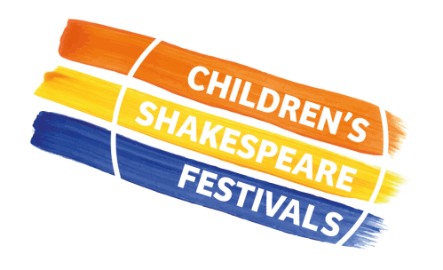 with our partner theatre and funders (who sometimes wish to use them in their own marketing and promotional materials). Sometimes we are asked to supply images for local or national press.

**HOW DO WE STORE THE PHOTOGRAPHS?**

NWD only store photographs taken during the Children’s Shakespeare Festivals on NWD owned equipment, and will only store it for 5 years. We give the photographs to your child’s school, who will make them available to parents/ carers inline with their own safeguarding policy and procedure.

**WHY DO WE PRINT CHILDREN’S NAMES IN THE PERFORMANCE PROGRAMME?**

On the day of the final performance, you will be able to purchase a programme, which features the names of all the schools, staff and pupils who take part. We do this to celebrate the children’s hard work and their performance. *We will only print your child’s name in the festival programme with your expressed consent*.

**Please complete yours and your child’s details below:**

|  |
| --- |
| **Name of child ……………………………………………………………………….. Age ………**  **Your relationship to child …………………………………………………………………………**  **Signature…………………………………………… Date………………………………………**  **Print your name** …………………………………………………… |

**Now please complete the other side of this form.**

**Please indicate your consent by ticking each statement below.**

|  |  |
| --- | --- |
| I give permission for North West Drama to take photographs of or film my child and to store these for five years. I understand the images/ footage may be used as follows: | |
|  | **to record my child’s participation in an activity** |
|  | **to share with me as their parent/carer or other parents/carers of children involved in the project** |
|  | **to include in a programme or other similar publication** |
|  | **to add to North West Drama’s images archive** |
|  | **to include in North West Drama’s promotional materials; in print or online** |
|  | **for use on North West Drama’s social media platforms** |
|  | **for use for fundraising activity, including sharing with sponsors and supporters** |
|  | **to include in North West Drama’s public displays or exhibitions** |
|  | **by our partner theatres in their own print or online promotional** |
|  | **for use in media print or online platforms** |

|  |  |
| --- | --- |
| I give permission for my child’s school to share my child’s name with North West Drama so that they can print it in the performance programme, and for this to be stored for one year: | |
|  | **I give consent for my child’s name to be printed in the performance programme** |

|  |  |
| --- | --- |
| I give permission for North West Drama to interview my child about the work they are taking part in, or for them to be interviewed by the media (with appropriate supervision): | |
|  | **I give consent for my child to be interviewed about the Children’s Shakespeare Festival by NWD or the media, if they are happy to do so** |

**HOW DO WE PROTECT DATA?**

North West Drama recognise our responsibility to ensure the safety of the children and young people with whom we work. We will never ask for data that we don’t have a specific need for, and it will always be stored on NWD owned equipment and will only be accessible to NWD staff.

We will take all reasonable steps to ensure data is used solely for the purpose intended. You have the right to withdraw your consent at any time. If you wish to do so please contact our creative producer, Matt Wardle: [matt@northwestdramaservices.co.uk](mailto:matt@northwestdramaservices.co.uk)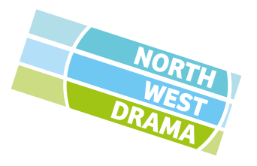

Please return this form, once complete, to your child’s teacher.